Peter Sanford

IT 2700  
NetLab Lab 21  
10/14/2023

1:

Step 7:

Step 10:

2:

Step 4:

Step 9:

Step 17:

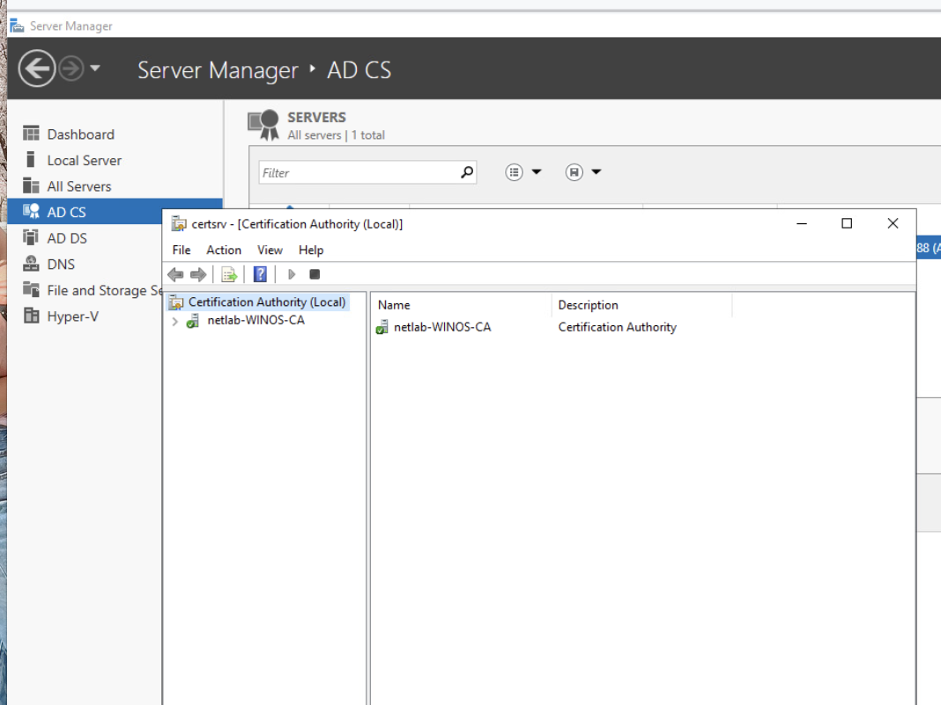

3.1:

Step 3:

3.2:

Step 4:

Step 8:

Step 14:

Step 19:

Commentary:

In this lab we managed and issued a CA and a web domain digital certificate. I learned that it isn’t too complicated but could become super complicated once you had a ton of certificates to manage. Luckily there’s PKI that can help with that though. Companies can use this information by using it to manage and request their own digital certificates. They probably shouldn’t have their own CA though since it wouldn’t be mutually trusted by other people on the internet (They wouldn’t recognize the CA issuer)